**ASSIGNMENT – 3**

**MODULE 6**

**S3 WEBSITE HOSTING**

**DONE BY**

**RANJITH KUMAR**

**Tasks To Be Performed:**

1. Use the created bucket in the previous task to host static websites, upload

an index.html file and error.html page.

2. Add a lifecycle rule for the bucket:

a. Transition from Standard to Standard-IA in 60 days

b. Expiration in 200 days

STEP 1 : Open S3 from aws services

STEP 2 : Select the ourbucket1 created from task1

STEP 3 : Select add files and add index.html and error.html files to the bucket

STEP 4 : Now select management > lifecycle rule > create lifecycle rule

STEP 5 : By default objects stores in a bucket used standard storage class

STEP 6 : Select object transition from standard to standard-IA in 60 days

STEP 7 : Select expiration after 200 days after creation

STEP 8 : Select bucket properties > static website hosting and enable it

STEP 9 : Now select permissions and allow public access and create a bucket policy to host a static website

STEP 10 : Copy the link and paste in the browser and check the website

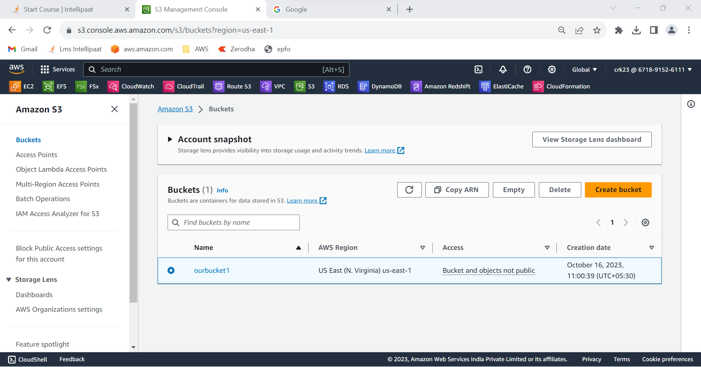

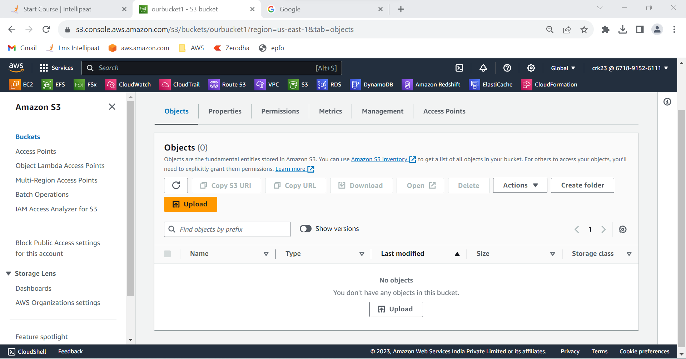

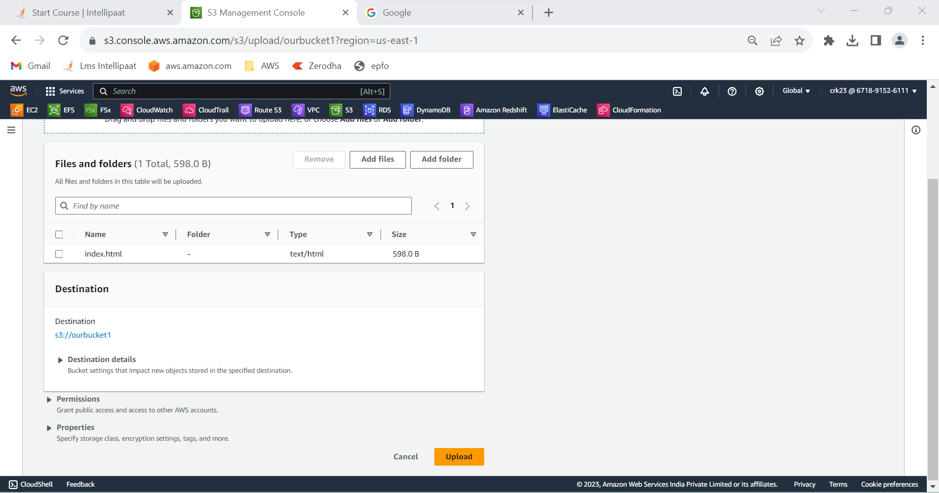

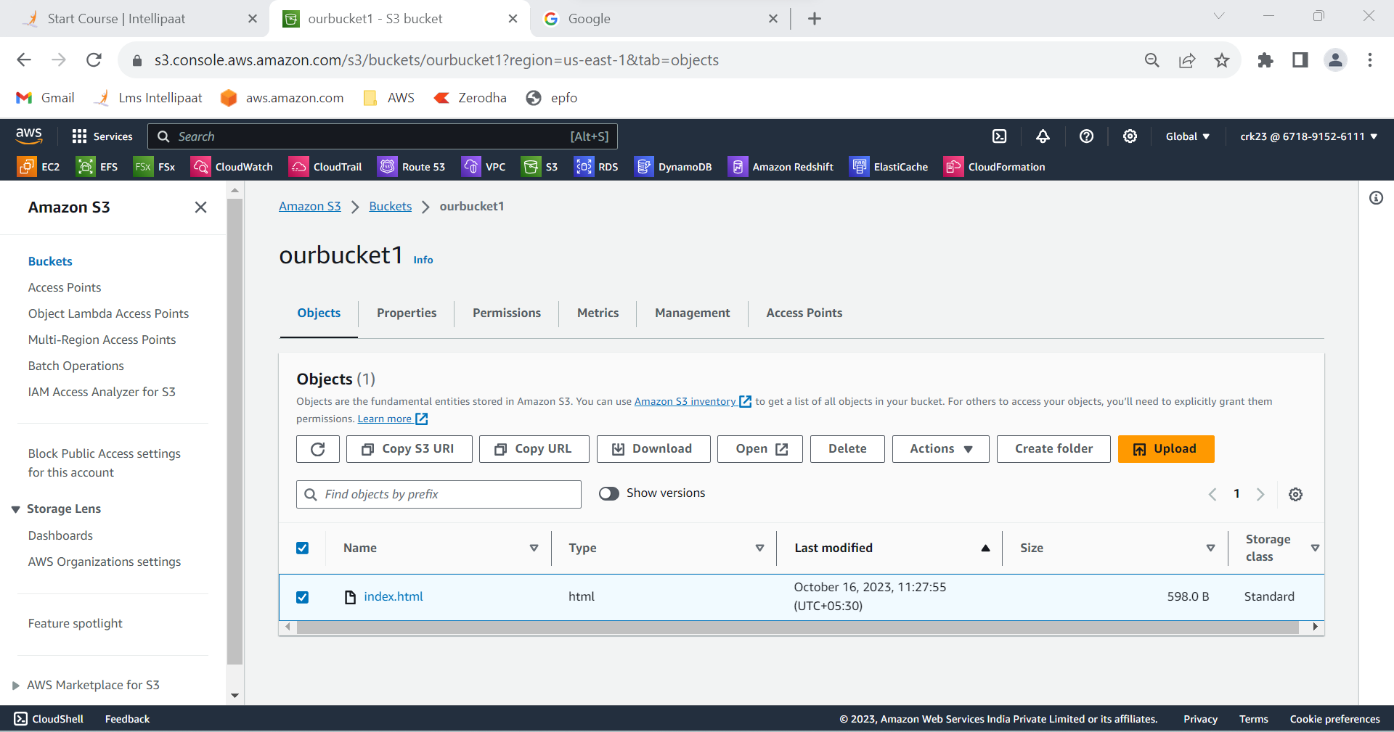

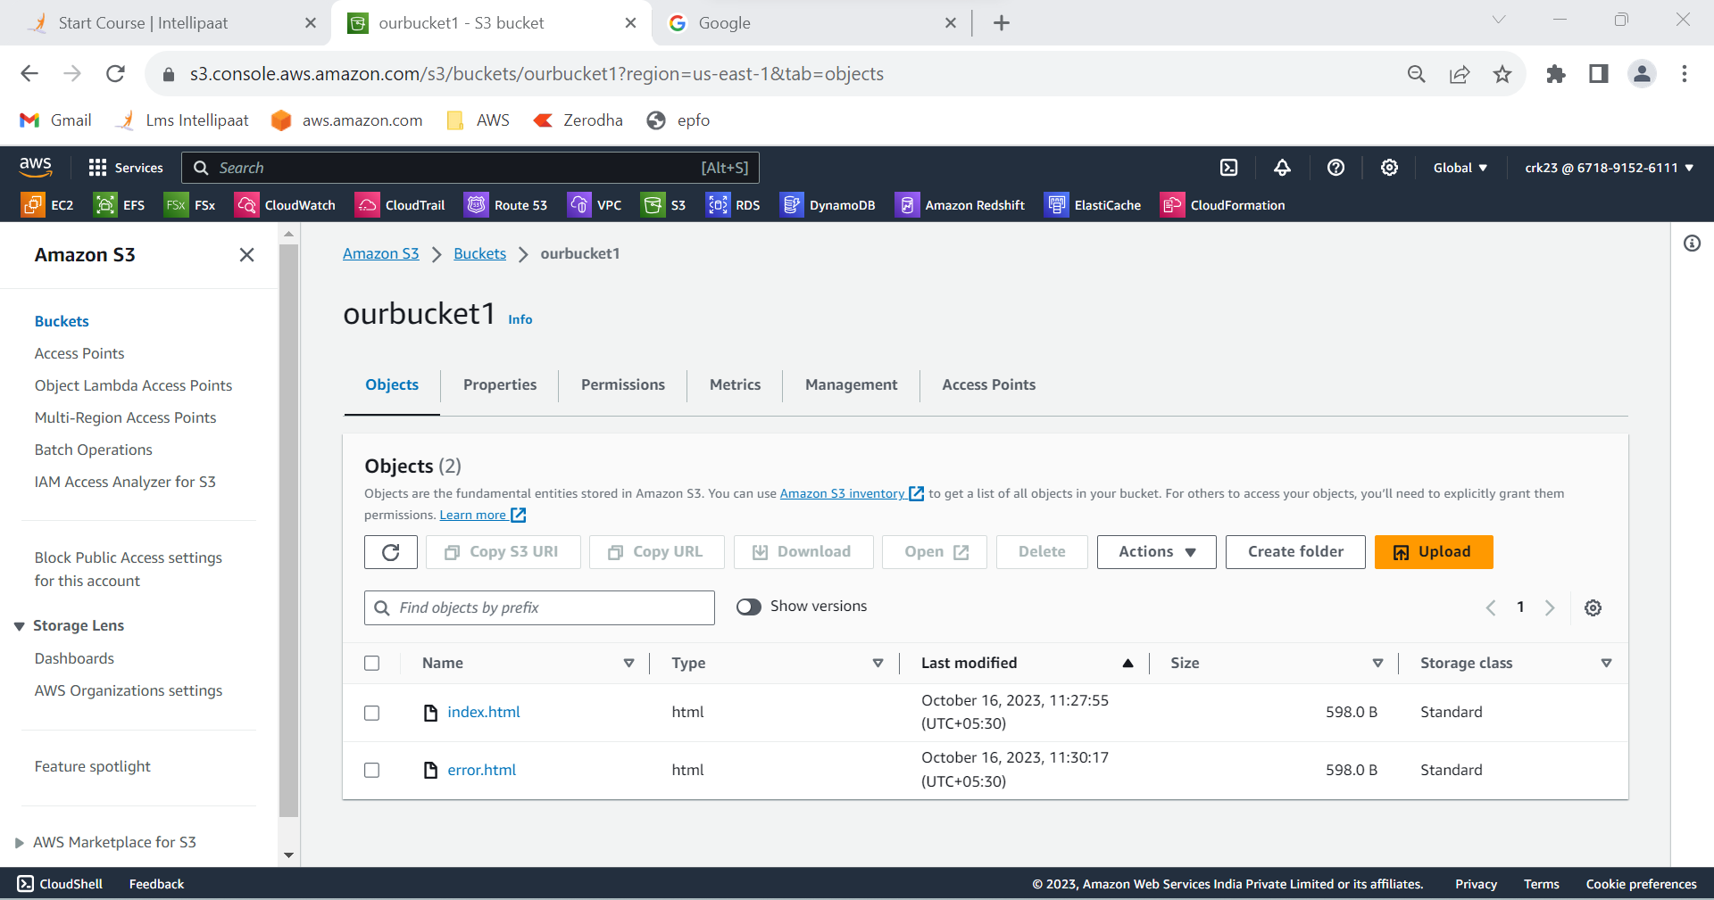

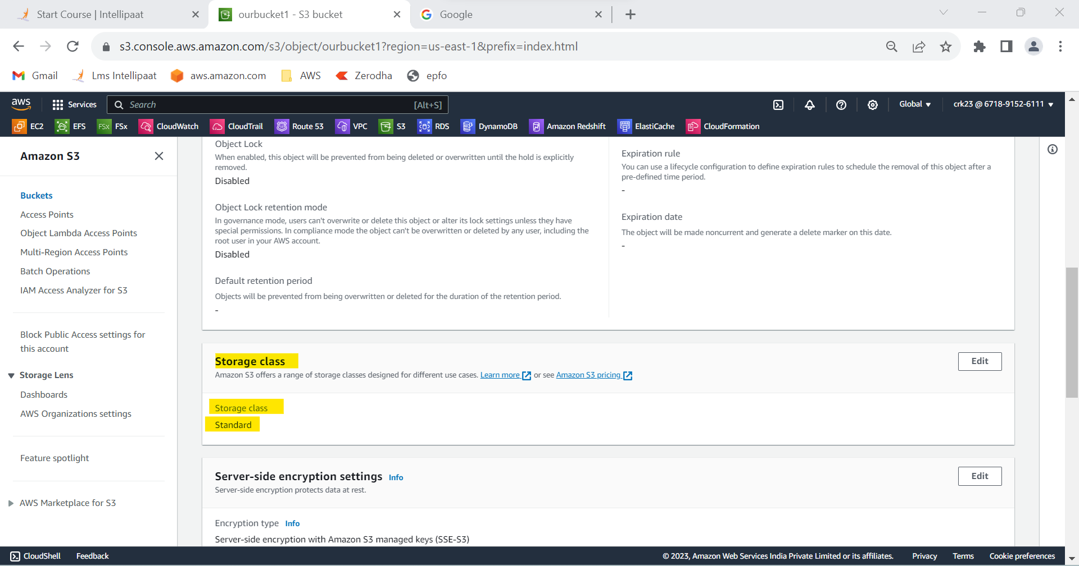

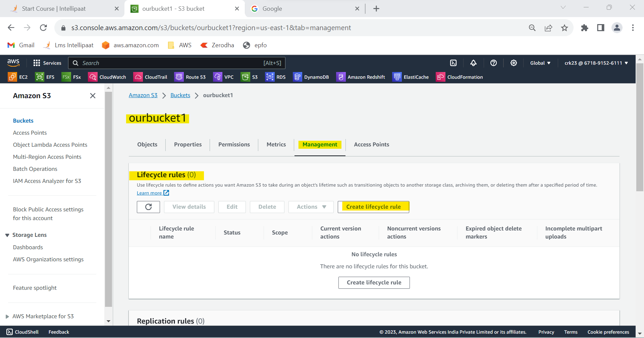

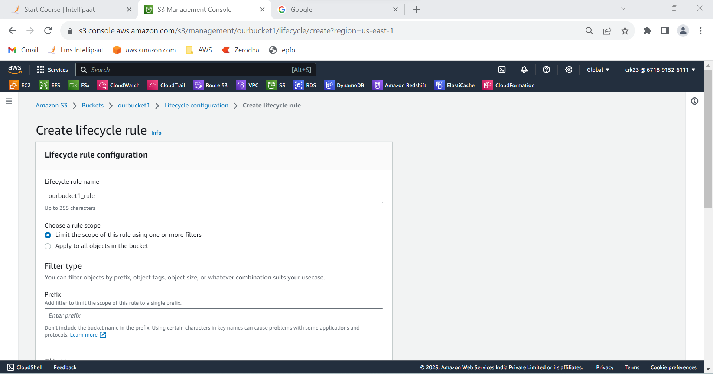

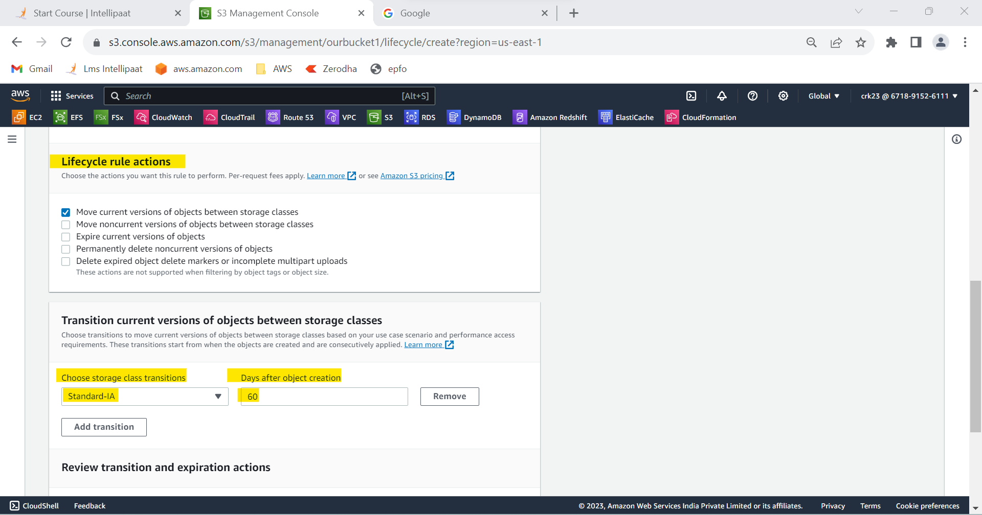

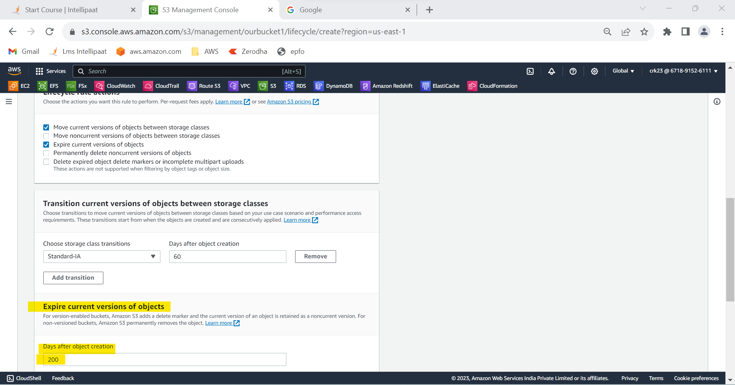

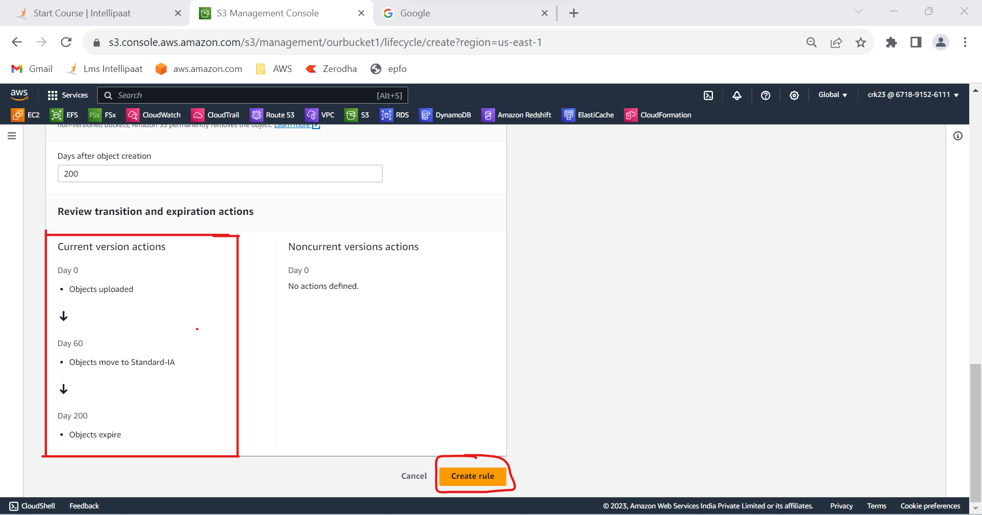

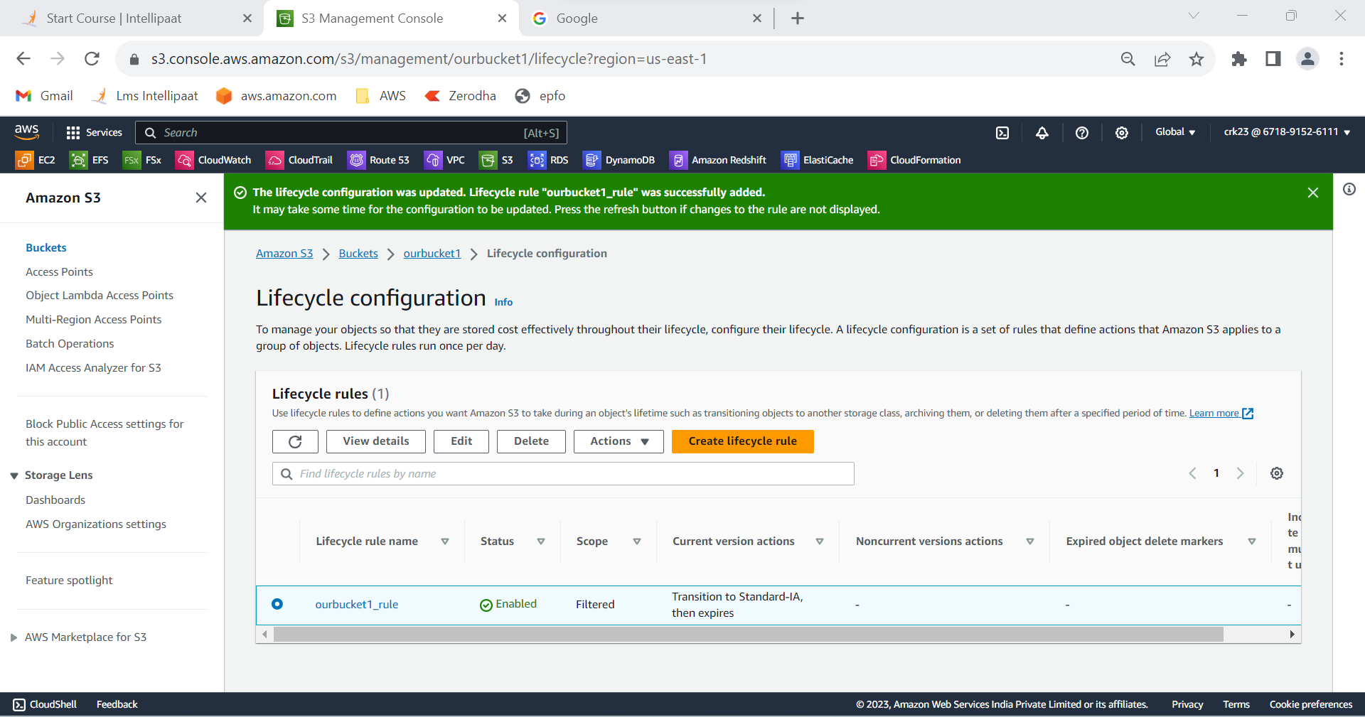

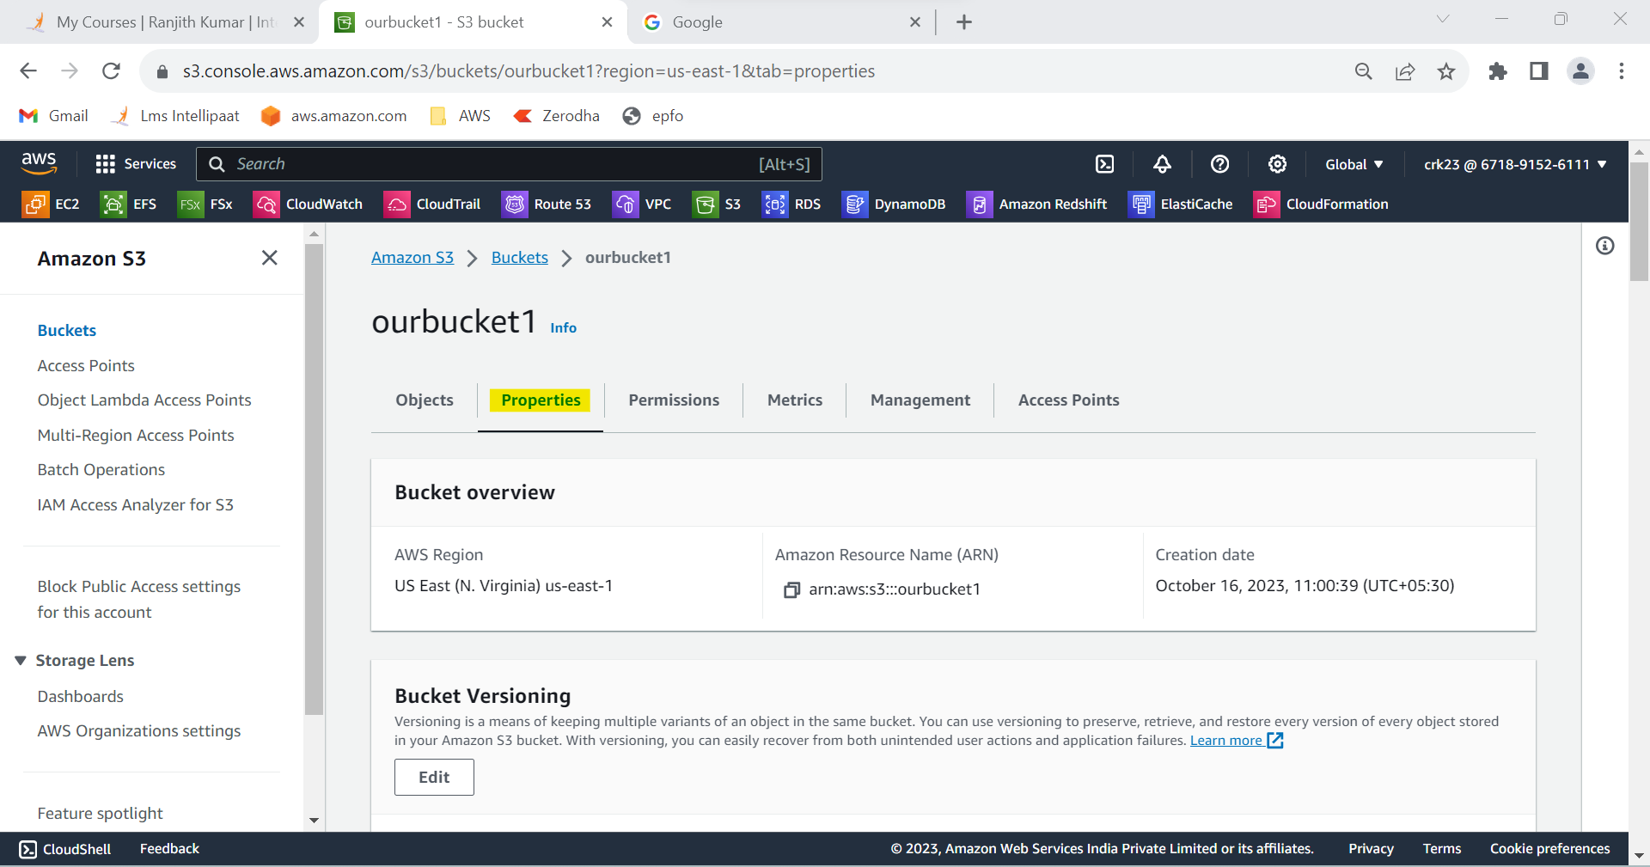

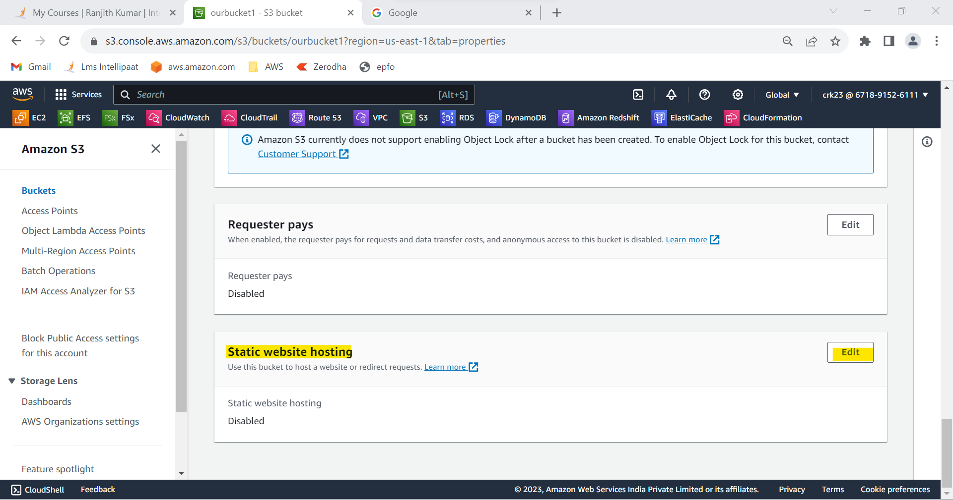

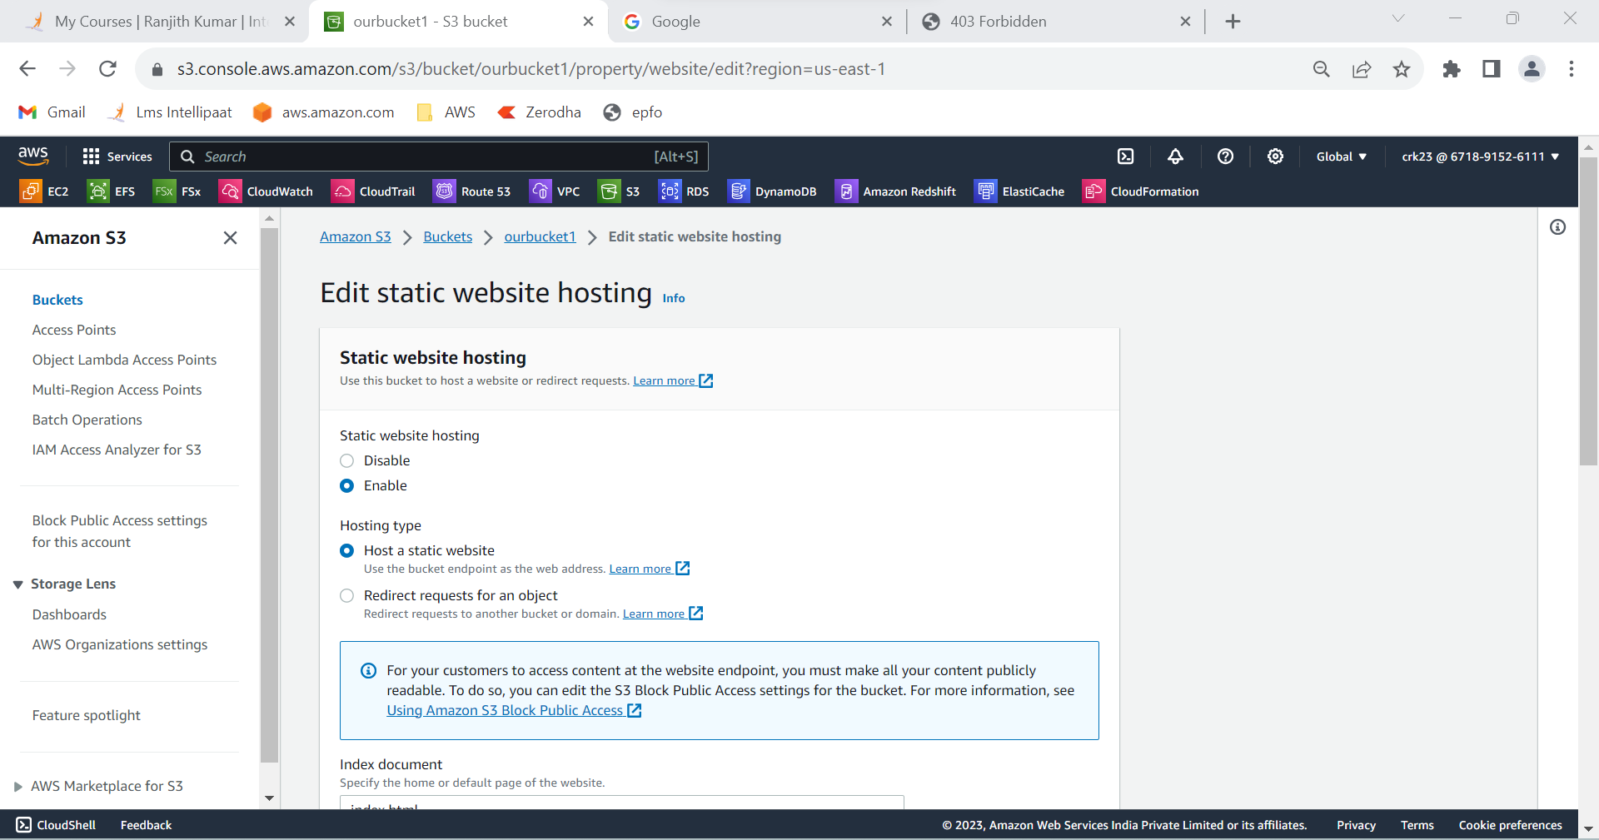

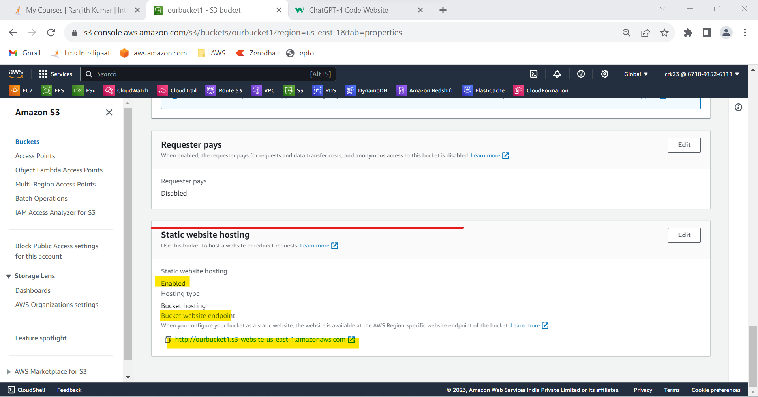

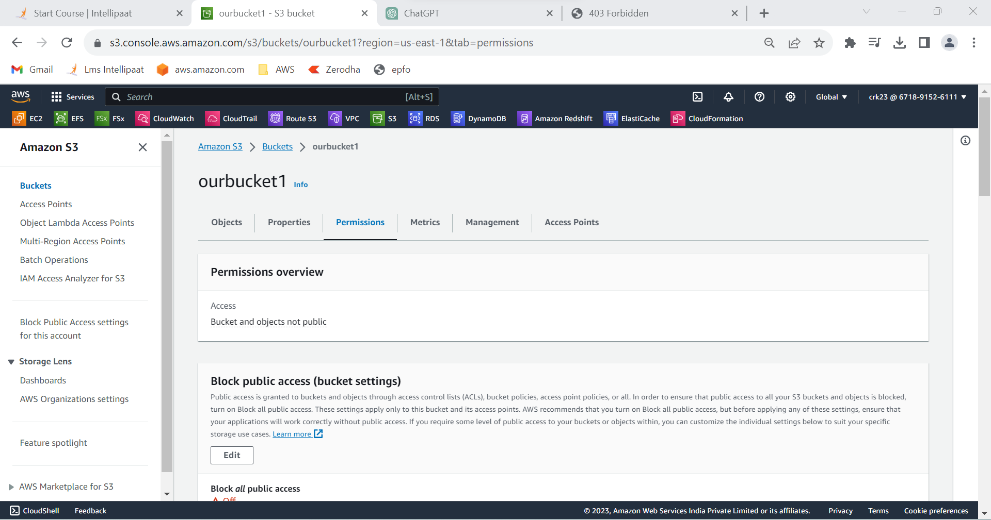

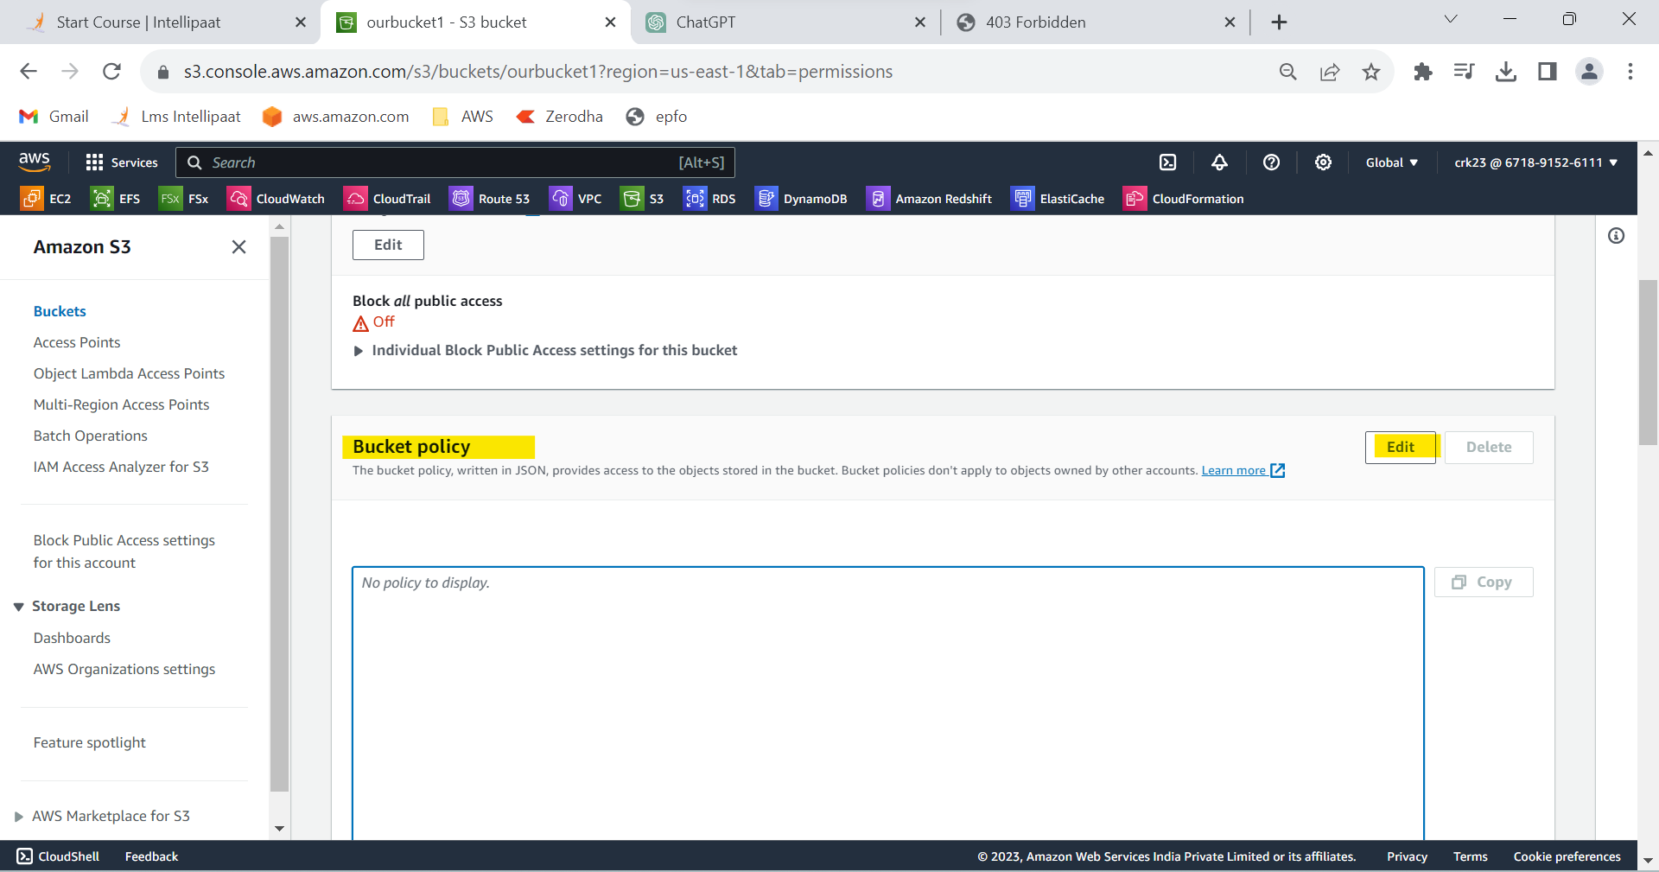

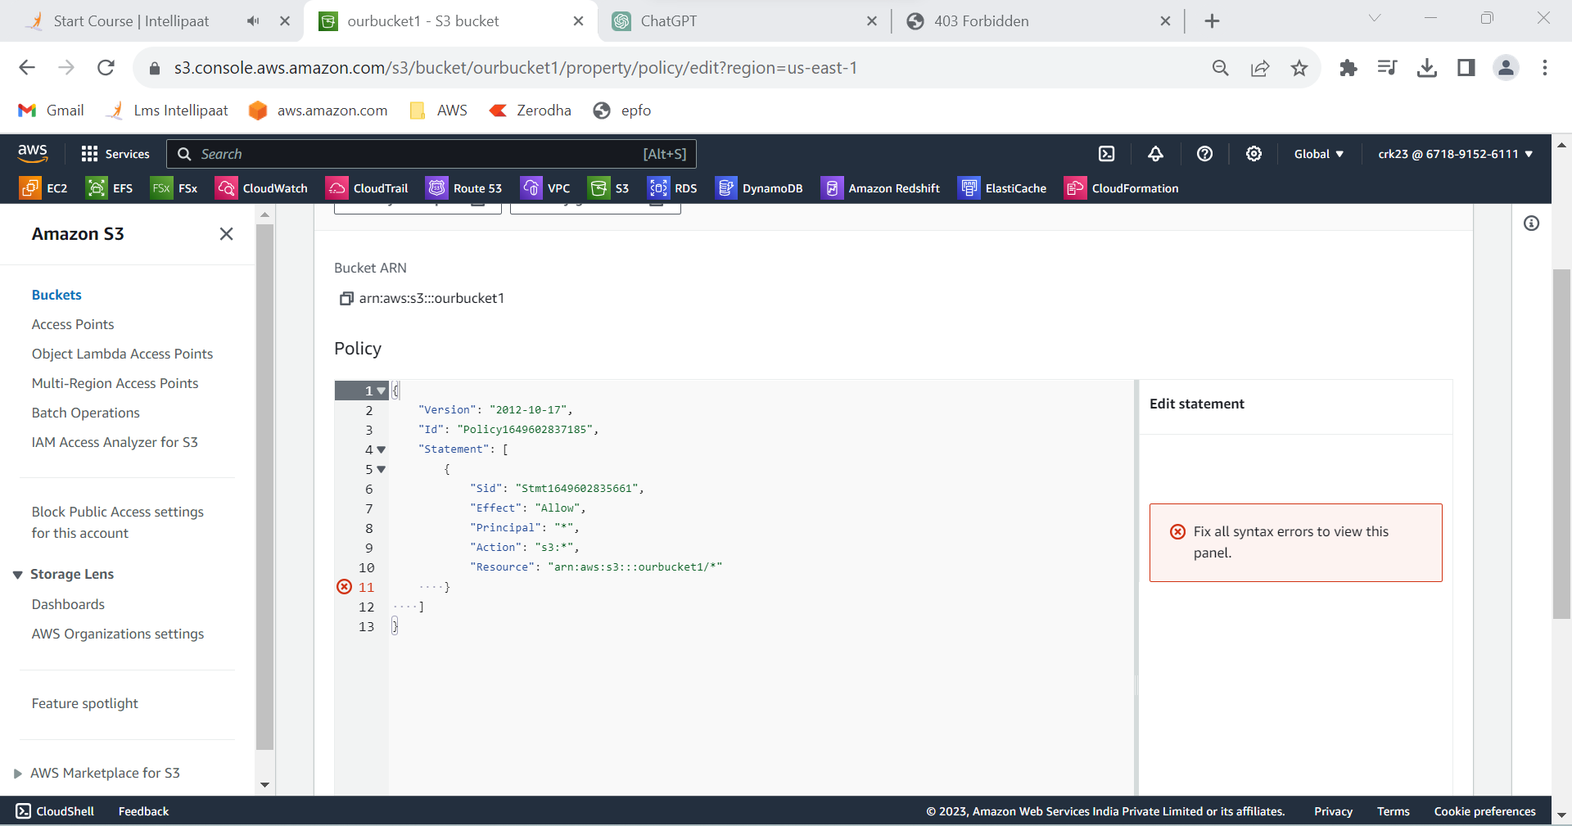

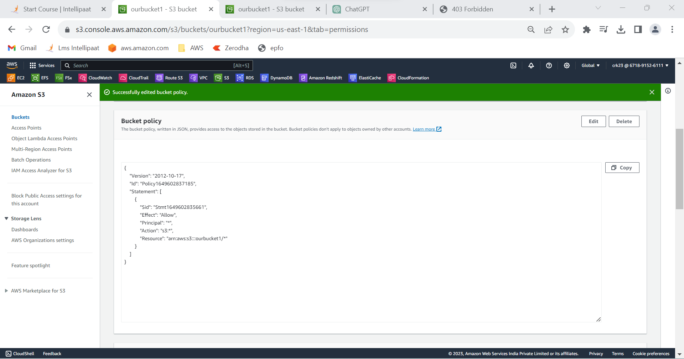

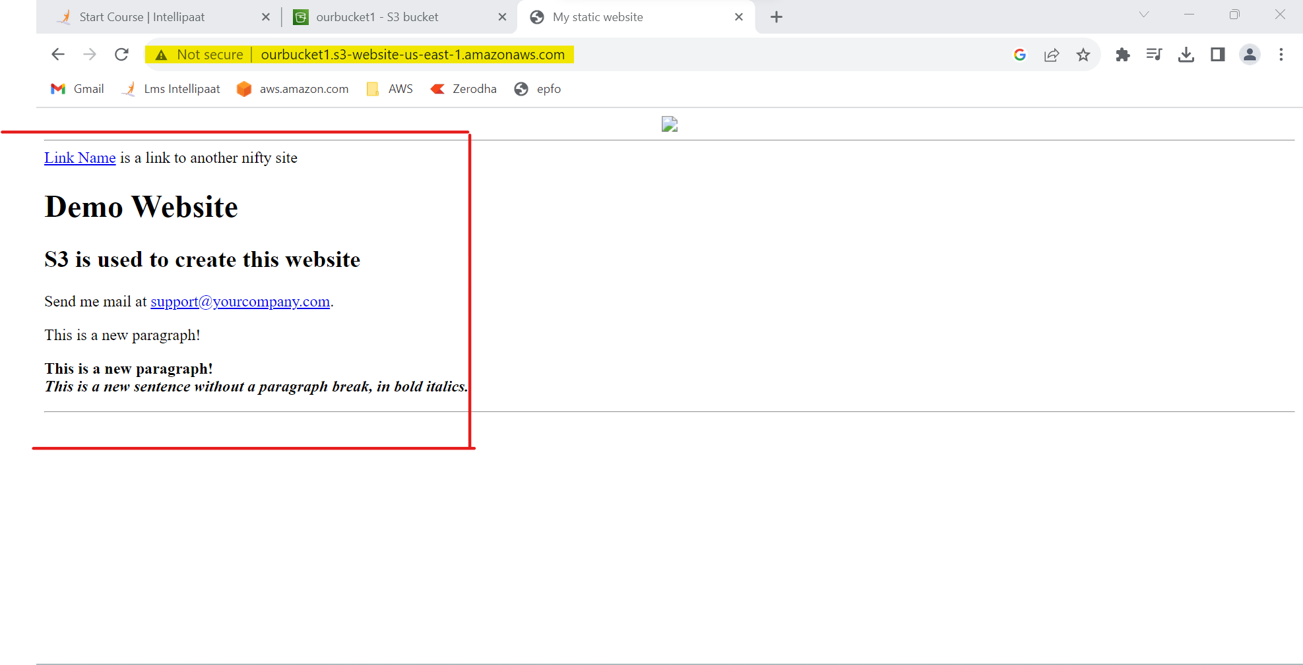

**OUTPUT:**

Used the created bucket in the previous task to host static websites, upload an index.html file and checked its working and added a lifecycle rule to our bucket to transit from standard to standard-IA storage class in 60 days and expiration in 200 days.